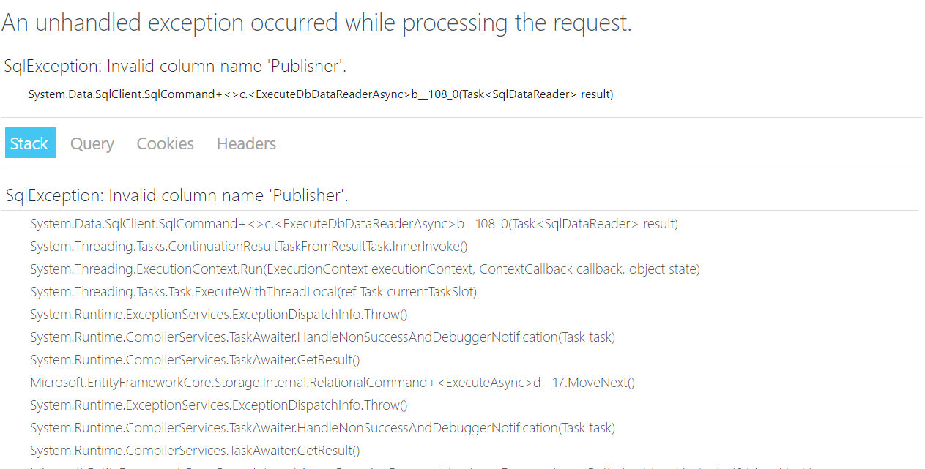  Lab number and date | Lab 8
Developer (Person whose code is being reviewed) | John Bell
URL for project repository (optional) | https://github.com/insidmal/CS295N/tree/master/Lab 8
URL for the hosted web app (optional) | http://bookcatalog20171113125732.azurewebsites.net/
Reviewer | Andrew Rogers
Instructions
The reviewer will complete this form for the beta version of a lab assignment done by one of their lab partners. After filling out the “Beta” column and adding comments, the reviewer will upload this document to the Lab Beta + Review Forum.
The developer will revise the beta version of their lab work and fill out the “Production” column to reflect any changes they have made. The developer will submit this completed form along with the production version of their lab assignment.
Criteria | Beta | Release
Does it compile and run without errors? (Yes, or No and list any issues below) | no | yes
Do all the web pages load correctly (for both POST and GET requests)? | no | yes
Do all the buttons and links work correctly? | First couple do | yes
Does the style conform to C# and Razor Page coding conventions? | yes | yes
Do the design and implementation conform to OOP best practices? | yes | yes
Does the solution meet all the requirements? | no | ues
Comments
I get errors when running. The index page is fine but once I hit the link to see the list I get errors. I included a snip of the error below. The code seems to look generally right at first glance, must be something minor.

I think Andrew just needed to run the update-database command, it works fine on my machine and on azure so should be good to go :)

Appendix
Aspects of coding style to check
- Is proper indentation used?
- Are the HTML elements and variables named descriptively?
- Have any unnecessary lines of code or files been removed?
- Are there explanatory comments in the code?
- Do variable names use camelCase?
- Are properties, methods and classes named using PascalCase (aka TitleCase)?
- Are constant names written using ALL_CAPS?
Best practices in Object Oriented Programming
- Is the code DRY (no duplicated blocks of code)?
- Are named constants used instead of repeated literal constants?
- Is code that does computation or logical operations separated into its own class instead of being added to the code-behind?
- Are all instance variables private?
- Are local variables used instead of instance variables wherever possible?
- Does each method do just one thing (no “Swiss Armey” methods)?
- Are classes “loosely coupled” and “highly coherent”?

